

Interface Control Document Template
Interface Design Document (IDD)
For <Target System Name (Acronym)>
Version Number: 1.0
Version Date: <mm/dd/yyyy>

Interface Design Document (IDD) Approval

The undersigned acknowledge that they have reviewed the <System Name> Interface Design Document and agree with the information presented within this document. Changes to the Interface Design Document will be coordinated with, and approved by, the undersigned, or their designated representatives.

Signature: |  | Date:
Print Name:
Title:
Role:

Signature: |  | Date:
Print Name:
Title:
Role:

Signature: |  | Date:
Print Name:
Title:
Role:

Revision History

This table records information regarding changes made to the document over time.

Version | Date | Organization/Point of Contact | Description of Changes
1.0 | <mm/dd/yy> | <Organization Identifier / Point-of-Contact Name> | Baseline Version

Table of Contents
1. Introduction 6
2. Overview 6
2.1 Interface Overview 6
2.2 Stakeholders 7
2.3 Statistics 7
2.4 Technical Specification 7
3. Assumptions, Constraints, Risks 8
3.1 Assumptions 8
3.2 Constraints 8
3.3 Risks 8
4. Interface Architecture 9
4.1 Logical View 9
4.2 Physical View 10
4.3 Security Approach 11
5. Interface Specifications 11
5.1 <Interface Name> Specification 12
5.1.1 Assumptions 12
5.1.2 General Processing Steps 12
5.1.3 Interface Processing Time Requirements 12
5.1.4 Message Format (or Record Layout) and Required Protocols 12
5.1.5 Communication Methods 14
5.1.6 Security Requirements 14
5.2 <Interface Name> Specification 15
6. Qualification Methods 15
7. Referenced Documents 15
8. Glossary 16
9. Acronyms 16
10. Appendices 16
10.1 Appendix A – Data Elements 16
10.1.1 Data Structure 16
10.1.2 Data Elements 17
10.2 Appendix B: Interface Requirements 18

LIST OF FIGURES

Figure 1: Logical Architecture View 11
Figure 2: Physical Architecture View 12

LIST OF TABLES

Table 1: Software Environment Requirements 9
Table 2: Risks & Mitigations 10
Table 3: Referenced Documents 16
Table 4: Glossary of Terms 17
Table 5: List of Acronyms 17

Introduction
This section provides identifying information for the source and target systems participating in the interface.
[A separate paragraph should be included for each system that comprises the interface, providing sufficient description to definitively identify the systems participating in the interface. Summarize the purpose of the document, the scope of activities that resulted in its development, the intended audience for the document, and expected evolution of the document. Also describe any security or privacy considerations associated with use of the IDD.]

This Interface Design Document (IDD) describes the relationship between the <Source System Name (Acronym)> (the source system) and the <Target System Name (Acronym)> (the target system).

This IDD specifies the interface requirements to be met by the participating systems. It describes the concept of operations for the interface, defines the message structure and protocols that govern the interchange of data, and identifies the communication paths along which the data are expected to flow.

For each interface, the following information will be provided:
- A general description of the interface;
- Assumptions where appropriate;
- A description of the data exchange format and protocol for exchange; and
- Estimated size and frequency of data exchange.

Overview
This section characterizes the system interface. Further information on the functionality and architecture of the participating systems is given in the subsequent sections.

Interface Overview
Interface Name: | [A concise meaningful name—something convenient for people to use in discussion].
Purpose: | [Purpose of interface]
Description: | [Description of interface]
Source System: | [Name of system initiating interface]
Target System: | [Name of system responding to interface]
Priority: | High/mandatory Medium/recommended Low/optional
Complexity | High Medium Low

Stakeholders
Stakeholder Role | Stakeholder Organization | Stakeholder Contact
Business Owner | [Organization of stakeholder] | [Stakeholder name]
Application Development | [Organization of stakeholder] | [Stakeholder name]
DBA | [Organization of stakeholder] | [Stakeholder name]

Statistics
Statistics | Statistics Value
Initial Installation Date: | [When did the interface go into production]
Last Release Date: | [When was the interface last released]
Frequency of Upgrades/Patches: | [How often is this interface changed?]
Interface Frequency: | Hourly Daily Weekly Monthly On-demand  Other (Specify) :

Technical Specification
Technical Attribute | Technical Specification
Standard Compliance: | [State the standard the interface must comply with (e.g. HL7). Also state the standard version (e.g. HL7 v3).]
Interface Type: | Batch (one-way transfer of accumulated data)  Near Real-Time (one-way message-based transfer of data)  Real Time (Immediate transfer of small data set)  Other (Specify) :
Method of Delivery: | File interface  Message-based  Direct data access  Other (Specify) :
Types of Records Sent: | Full record load (sends all records every time it is executed)  Delta full records (Only sends records that have changed since previous execution)  Other (Specify) :
Volume Estimate: | Average Volume:  Peak Volume:
Performance: | [How much is run through and how quickly – Timing, Response Time]
Solution Components: | [Solution components that implement interface]
Security Utilized: | [What security mechanisms/applications are used]
Error Handling: | [What error programs/procedures are utilized]
Known Issues: | [All known deficiencies and limitations]

Assumptions, Constraints, Risks

Assumptions
This section describes any assumptions or dependencies regarding the interfaces of the system.
[These may concern such issues as: related software or hardware, operating systems, or end-user characteristics.]

Constraints
This section describes any limitations or constraints that have significant impact on the system interfaces.
[Such constraints may be imposed by any of the following (the list is not exhaustive):
- Hardware or software environment
- End-user environment
- Availability of resources
- Interoperability requirements
- Interface/protocol requirements
- Data repository and distribution requirements]

Requirement | Provider | Solution | Purpose
Data Transformation | [Provider’s Name] | [Solution Name] | [Describe purpose]
Database | [Provider’s Name] | [Solution Name] | [Describe purpose]
Digital Signature | [Provider’s Name] | [Solution Name] | [Describe purpose]
Error Handling | [Provider’s Name] | [Solution Name] | [Describe purpose]
Job Scheduling | [Provider’s Name] | [Solution Name] | [Describe purpose]
Messaging | [Provider’s Name] | [Solution Name] | [Describe purpose]
Security | [Provider’s Name] | [Solution Name] | [Describe purpose]
Table 1: Software Environment Requirements

Risks
Table 2: Risks & Mitigations describes any risks associated with the system interfaces and proposed mitigation strategies.
Risk # | Risk Statement | Risk Mitigation Strategy
Risk 1 | External system has inconsistent expectations | - Interface Design Document defined and all system owners approve
Risk 2 | External system unavailable | - IDD includes availability requirements  - Design incorporates retry logic
Risk 3 | External system sends invalid data | - IDD includes data validation rules  - Solution enforces data validation rules  - Solution includes exception processing queue  - Operations monitor & resolve exceptions
Risk 4 | Interface doesn’t process data in a timely manner | - IDD includes throughput requirements  - Test cases includes performance tests  - Operations monitor interface performance
[Ref #] | [Statement of risk] | [Describes methods to reduce risk]
Table 2: Risks & Mitigations

Interface Architecture
This section describes the functionality and architecture of the interfacing systems as they relate to the overall approach to interfaces between the two systems. Section 4.3 describes interface-specific design elements.

Logical View
This section describes the logical architecture of the interfacing systems.
[Replace diagram and add associated text to describe each interaction/message.]
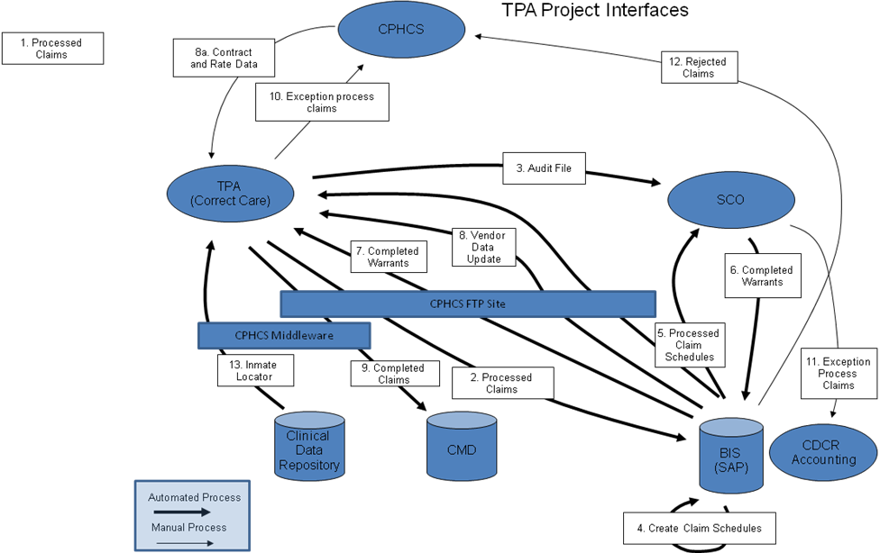
Figure 1: Logical Architecture View

Physical View
This section describes the physical architecture of the interfacing systems, focusing on the software components that comprise the application architecture to support all the interactions/messages.
[Replace diagram and add associated text to describe each hardware/software component.]
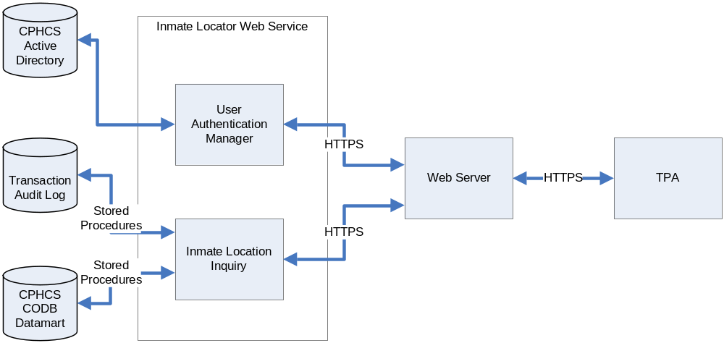
Figure 2: Physical Architecture View

Security Approach
This section describes how security is implemented and how data transmission security is implemented between the two (2) interfacing systems.

Interface Specifications
This section specifies the requirements for one or more interfaces between two systems.
[This includes explicit definition of the content and format of every message or file that may pass between the two systems, and the conditions under which each message or file is to be sent. If an interface between the two systems is to be implemented incrementally, identify the implementation phase in which each message will be available. The structure in Section 6.1 should be replicated for each defined interface between the two participating systems.

The template contained in Section 6.1 (including subsections) provides a generic approach to interface requirements definition. The specific interface definition should include only subsections relevant to the interface being defined, and liberty may be taken in the organization of Section 6.1 subsections. Where types of information not specified in Section 6.1 are required to clearly define the interface, additional subsections should be added. Other readily available documents (such as data dictionaries, standards for commercial protocols, and standards for user interfaces) may be referenced instead of stating the information here. It may be useful to include copies of such documentation as appendices to the IDD. Where possible, the use of tables and figures is encouraged to enhance the understandability of the interface definition. In defining interface requirements, clearly state which of the interfacing systems the requirement is being imposed upon.]

<Interface Name> Specification
[Briefly summarize the interface. Indicate what data protocol, communication methods, and processing priority are used by the interface. Data protocols may include messages and custom ASCII files. Communication methods may include electronic networks or magnetic media.]

Assumptions
[Identify any assumptions that specify organizational responsibilities for specific activities or decisions, or that defines specific constraints. Assumptions might include:
- Data acceptance constraints
- Responsibility for establishing and managing the communication protocol.
- Responsibility for providing and/or accepting file feeds for test and production processing.
- Allowable file sizes.
- Responsibility for decisions on acceptance of test results.]

General Processing Steps
[Describe the daily, weekly, monthly, etc., and threshold processing. Discuss the process to be used to confirm successful file transmission. Identify steps to be taken if all records in a file are received and the steps to be taken if all records are not received. Identify the reports to be used to document the results of daily, weekly, monthly, etc., processing. Describe any special processing that will be performed if a certain percentage (threshold) of the records is rejected.]

Interface Processing Time Requirements
[If information is required to be formatted and communicated as the data is created, as a batch of data is created by operator action, or in accordance with some periodic schedule, indicate processing priority. Requirements for specific messages or files to be delivered to the communications medium within a set interval of time should be included in Subsection 6.1.4. State the priority that the interfacing entities must assign to the interface. Priority may be stated as performance or response time requirements defining how quickly incoming traffic or data requests must be processed by the interfacing system to meet the requirements of the interface. Considerable latitude should be given in defining performance requirements to account for differences in hardware and transaction volumes at different installation sites of the interfacing systems. Response time requirements, which are impacted by resources and beyond the control of the interfacing systems (i.e., communication networks), are beyond the scope of an IDD.]

Message Format (or Record Layout) and Required Protocols
[Specify the explicit definitions of and the conditions under which each message is to be sent. Describe the definition, characteristics, and attributes of the command. Also document query and response descriptions.]

File Layout
[This section should contain diagrams and short descriptions of both the header and detail layouts. This information may be included in an appendix to the document that is referenced here.]

Data Assembly Characteristics
This section defines the content and format of every message, file, and/or record that is used by the interface. See Appendix A – Data Elements for additional information on the data structures and data elements.
[In defining interfaces where data is moved among systems, define the packaging of data to be utilized. The origin, structure, and processing of such packets will be dependent on the techniques used to implement the interface. Define required characteristics of data element assemblies that the interfacing entities must provide, store, send, access, receive, etc. When relevant to the packaging technique used, the following information should be provided:
- Names/identifiers
- Project-unique identifier
- Non-technical (natural language) name
- Technical name (e.g., record or data structure name in code or database)
- Abbreviations or synonymous names
- Structure of data element assembly (e.g., field name, type, length, valid values, etc.)
- Visual and auditory characteristics of displays and other outputs (e.g., colors, layouts, fonts, icons, and other display elements, beeps, lights) where relevant
- Relationships among different types of data element assemblies used for the interface
- Priority, timing, frequency, volume, sequencing, and other constraints (e.g., whether the assembly may be updated and whether business rules apply)
- Sources (setting/sending entities) and recipients (using/receiving entities)]

Field/Element Definition
[Define the characteristics of individual data elements that comprise the data packets defined in Subsection 6.1.4.2. Sections 6.1.4.2 and 6.1.4.3 may be combined into one section in which the data packets and their component data elements are defined in a single table. Data element definitions should include only features relevant to the interface being defined and may include such features as:
- Names/identifiers
- Project-unique identifier
- Priority, timing, frequency, volume, sequencing, and other constraints (e.g., whether the data element may be updated and whether business rules apply)
- Non-technical (natural language) name
- Technical name (e.g., variable or field name in code or database)
- Abbreviation or synonymous names
- Data type (alphanumeric, integer, etc.)
- Size and format (e.g., length and punctuation of a character string)
- Units of measurement (e.g., meters, dollars, nanoseconds)
- Range or enumeration of possible values (e.g., 0-99)
- Accuracy (how correct) and precision (number of significant digits)
- Security and privacy constraints
- Sources (setting/sending entities) and recipients (using/receiving entities)
- Validation rule(s)
If there is a need to reformat data before they are transmitted or after incoming data is received, include descriptions of the tools and/or methods for the reformatting process.]

Communication Methods
[Communication requirements include all aspects of the presentation, session, network, and data layers of the communication stack to which both systems participating in the interface must conform. Document the specifications for hand-shaking protocols between the two systems. Include the content and format of the information to be included in the hand-shake messages, the timing for exchanging these messages, and the steps to be taken when errors are identified. The following subsections should be included in this discussion as appropriate to the interface being defined and may be supplemented by additional information as appropriate.]

Interface Initiation
[Define the sequence of events by which the connections between the participating systems will be initiated. Include the minimum and maximum number of conceptions that may be supported by the interface. Also include availability requirements for the interface (e.g., 24 hours a day, 7 days a week) that are dependent on the interfacing systems. Availability requirements beyond the control of the interfacing systems (e.g., network availability) are beyond the scope of an IDD.]

Flow Control
[Specify the sequence numbering, legality checks, error control, and recovery procedures that will be used to manage the interface. Include any acknowledgement (ACK/NAK) messages related to these procedures. Address the format(s) for error reports exchanged between the systems and their disposition (e.g., retained in a file, sent to a printer, flag/alarm sent to the operator, etc.).]

Security Requirements
This section specifies the security features that are required to be implemented within the message or file structure or in the communications processes.
[Specify the security of the communication methods used (Include safety/security/privacy considerations, such as encryption, user authentication, compartmentalization, and auditing). For interactive interfaces, security features may include identification, authentication, encryption, and auditing. Simple message broadcast or ASCII file transfer interfaces are likely to rely on features provided by communication services. Do not specify the requirements for features that are not provided by the systems to which the IDD applies. Specifically state if the interface relies solely on physical security or on the security of the networks and firewalls through which the systems are connected.]

<Interface Name> Specification
[All of the applicable characteristics described in section 6.1 should be replicated for each defined interface between the two participating systems. There is no limit on the number of unique interfaces that can be defined in a single IDD. In general, all interfaces defined should involve the same two systems.]

Qualification Methods
[This section defines a set of qualification methods to be used to verify that the requirements for the interfaces defined in Section 6 have been met. Qualification methods include:

Demonstration – The operation of interfacing entities that relies on observable functional operation not requiring the use of instrumentation, special test equipment, or subsequent analysis.

Test – The operation of interfacing entities using instrumentation or special test equipment to collect data for later analysis.

Analysis – The processing of accumulated data obtained from other qualification methods. Examples are reduction, interpretation, or extrapolation of test results.

Inspection – The visual examination of interfacing entities, documentation, etc.

Special Qualification Methods – Any special qualification methods for the interfacing entities (e.g., special tools, techniques, procedures, facilities, and acceptance limits).]

Referenced Documents
Table 3: Referenced Documents lists all documents used to arrive at and/or referenced within this document (e.g., related and/or companion documents, prerequisite documents, relevant technical documentation, etc.).

Document Name | Issuance Date
<System Name> High-Level Solution Design | <Month Day, Year>
<System Name> Requirements Document | <Month Day, Year>
<System Name> System Design Document (SDD) | <Month Day, Year>
Table 3: Referenced Documents

Glossary
Table 4: Glossary of Terms provides clear and concise definitions for terms used in this document that may be unfamiliar to readers of the document.

Glossary Term | Definition
Interface | An interface, from the perspective of system development, can be identified as any point where a system and something, or someone, meet. This interface point may include other systems or users. Interfaces are documented using Interface Design Documents (IDD).
Table 4: Glossary of Terms

Acronyms
This section provides a list of acronyms and associated literal translations used within the document.
Acronym | Literal Translation
IDD | Interface Design Document
SDD | System Design Document
Table 5: List of Acronyms

Appendices
[Utilize appendices to facilitate ease of use and maintenance of the IDD document. Each appendix should be referenced in the main body of the document where that information would normally have been provided.]

Appendix A – Data Elements

Data Structure
Identify the data structure.
State | Usage | Type | Units | Description
x | Internal | Char | Seconds
y | Developers | double | Feet
z | Developers | double | Feet

Data Elements
Identify the data elements:
Field Name | Field Length | Position | Data Type | Functional Description
Name | 50 | Delimited | A-Numeric | Last name, first, middle, suffix.
SSN | 10 | Delimited | A-Numeric | Social Security Number
Birth Date | 8 | Delimited | A-Numeric | Date of birth. Format: YYYYMMDD.
Status | 8 | Delimited | A-Numeric | Date of the status. Format: YYYYMMDD.

Appendix B: Interface Requirements
Label | Priority | Requirement Statement | Owner | Status | Type | Source
[Req ID] | [Required/ Desired] | <Data description> shall be stored <Manner of storage> for <Retention duration> from <Duration start trigger>. | [Owner] | Proposed | Non-Functional: Data Management | [Source]
[Req ID] | [Required/ Desired] | Each «Operation type» shall have a response time of no more than «Tolerable length of time» from «Timing boundary start» to «Timing boundary end» [when using «Indicative hardware set-up»]. This figure is based on «Justification». [This requirement does not apply to «Exceptional cases».] | [Owner] | Proposed | Non-Functional: Performance | [Source]
[Req ID] | [Required/ Desired] | Average time of <transaction completion> shall not be greater than <time period>. | [Owner] | Proposed | Non-Functional: Performance | [Source]
[Req ID] | [Required/ Desired] | The solution shall <transaction completion> within <time range>. | [Owner] | Proposed | Non-Functional: Performance | [Source]
[Req ID] | [Required/ Desired] | «Part of system» shall be able to handle «Throughput object type» transactions at a rate of at least «Throughput quantity» per «Unit time period» [when using «Indicative hardware set-up»]. [«Target achievement timeframe statement».] [«Contingency statement».] | [Owner] | Proposed | Non-Functional: Performance | [Source]
[Req ID] | [Required/ Desired] | The system shall accommodate <number> <transaction type> per <time period>. | [Owner] | Proposed | Non-Functional: Capacity | [Source]
[Req ID] | [Required/ Desired] | The system shall normally be available to users «Availability extent description» [, except in exceptional circumstances of a frequency and duration not to exceed «Tolerated downtime qualifier»]. “Normally available” shall be taken to mean «Availability meaning». | [Owner] | Proposed | Non-Functional: Availability | [Source]
[Req ID] | [Required/ Desired] | Percentage of time the system is available, mean time between errors. The <<system name/component>> shall be at least <<duration>>. | [Owner] | Proposed | Non-Functional: Availability | [Source]
[Req ID] | [Required/ Desired] | The <<system name/component>> shall be available <percent>% of the time. | [Owner] | Proposed | Non-Functional: Availability | [Source]
[Req ID] | [Required/ Desired] | The solution shall support <number><unit of message> of <message type> between <other system>. | [Owner] | Proposed | Non-Functional: Capacity | [Source]
[Req ID] | [Required/ Desired] | In case of a system failure, a redundant system shall resume operations within <time period>. | [Owner] | Proposed | Non-Functional: Recoverability | [Source]
[Req ID] | [Required/ Desired] | <Requirement that defines the verification of the identity of the sender> | [Owner] | Proposed | Security | [Source]
[Req ID] | [Required/ Desired] | <Requirement to log incoming and outgoing messages> | [Owner] | Proposed | Functional | [Source]
[Req ID] | [Required/ Desired] | <Requirement to acknowledge receipt of messages> | [Owner] | Proposed | Functional | [Source]
[Req ID] | [Required/ Desired] | <Requirement for interfacing software to support multiple versions of a message to accommodate upgrades. > | [Owner] | Proposed | Non-Functional: Extensibility | [Source]
[Req ID] | [Required/ Desired] | <Requirement for testing interface> | [Owner] | Proposed | Non-Functional: Testability | [Source]
[Req ID] | [Required/ Desired] | <Requirement for reporting errors> | [Owner] | Proposed | Non-Functional: Supportability | [Source]
[Req ID] | [Required/ Desired] | <Requirement for network protocol (e.g. TCP/IP> | [Owner] | Proposed | Non-Functional: Architecture | [Source]
[Req ID] | [Required/ Desired] | The solution must comply with WS-I Security Profile. | [Owner] | Proposed | Non-Functional: Interoperability | [Source]
[Req ID] | [Required/ Desired] | The solution must comply with HIPAA privacy requirements. | [Owner] | Proposed | Security | [Source]
[Req ID] | [Required/ Desired] | The solution must comply with HIPAA security requirements. | [Owner] | Proposed | Security | [Source]

